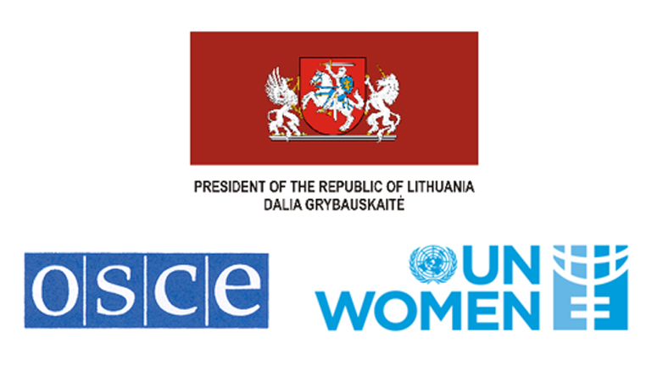

Regional Conference and Consultations on

UNSCR 1325 implementation in the OSCE region

Dates: 19 to 20 April 2015
Venue: Presidential Palace, Vilnius, Lithuania

AGENDA
19 April
19.00 Welcome Reception
Hotel Radisson Blu Royal Astorija at the Hall Simfonija
Address: Didžioji g. 35/2
LT-01128 Vilnius

20 April

8:00 – 8:50 Registration of participants

9.00 – 10.30 Official Event with Opening:

Introducer: Giedrius Čekuolis, Permanent Representative of the Republic of Lithuania to the OSCE

Speakers:
- Dalia Grybauskaite, Lithuanian President
- Lamberto Zannier, Secretary General, OSCE
- Michael Georg Link, Director of Office for Democratic Institutions and Human Rights (ODIHR)
- OSCE Chairmanship
- Ingibjorg Gisladottir, Regional Director for Europe and Central Asia at UN Women

Welcoming notes by:
- Dalia Leinarte, Professor, Lithuanian representative in CEDAW
- Miroslava Beham, Senior Adviser on Gender Issues, OSCE

Key note speech by:
- Radhika Coomaraswamy, Lead Author of UN Global Study on the implementation of UNSCR 1325

10.30 – 11.00 Coffee break

11:00 – 12:30 Session 1. Action Plans for implementation of UN Security Council Resolution 1325 – best practices and lessons learnt

Moderator: Rasa Ostrauskaite, Deputy Director Conflict Prevention Centre, OSCE

Speakers:
- Bjørg Skotnes, Senior Adviser/ Coordinator Women, Peace and Security Norwegian Ministry of Foreign Affairs
- Dubravka Šimonović, Permanent Representative of the Mission of the Republic of Croatian to the OSCE

Moderated discussions:
- Good practices – what has been the impact of action plans in the region? What has worked and should be a lesson learned, both for the development and the implementation of NAPs?
- Challenges – one of the main challenges in the region has been that the WPS is “housed” within the social sector, without much responsibility from other line Ministries. This is especially the case for NAPs that do not indicate a budget and don’t have clearly assigned responsibilities and monitoring committees. How have these challenges been overcome?
- Beyond NAPs, what are other good practices and challenges for the implementation of the resolution? What strategies have worked to overcome these?
- Timing and ownership of action plans. The development of successful action plans requires a careful approach with regards to its timing (neither too early nor too late) and methodology. Ideally, the processes around the development of these plans build ownership and partnerships from different sectors and groups on WPS issues, especially between the government, CSOs and survivors. What good practices and lessons learnt can be shared in this regard?
- How has the policy framework for security changed in the OSCE region since the adoption of the resolution?
- What is the role of the Women, Peace and Security agenda in the changing security climate in the OSCE region?

12:30 – 14:30 Lunch Break with side event on Ukraine and the relevance on UNSCR 1325

13:00 – 14:30 Side event: Women’s Role in Peacebuilding in Ukraine
Moderated by Miroslava Beham, Senior Adviser on Gender Issues, OSCE

Speakers
- Sergiy Kyslytsya, Deputy Minister of Foreign Affairs, Ukraine
- Ertugrul Apakan, Chief Monitor, OSCE Special Monitoring Mission to Ukraine
- Marija Ionova, Member of Parliament, Ukraine
- Nataliia Bohdanova, Head of the Division on Gender Policy, Ministry of Social Policy of Ukraine

14:30 – 16:00 Session 2. Women, peace and security in the context of increasingly militarized approaches to conflict

Moderator: Zulema Altamirano Argudo, Seconded National Expert, European Institute for Gender Equality (EIGE)

Speakers:
- Antonia Potter Prentice, Senior Manager Gender and Inclusion, Crisis Management Initiative, Finland
- Julia Kharashvili, Member of High Level Advisory Group for Global Study on the impact of UNSC Resolution 1325, Georgia.

Moderated discussions:
- The last decade has seen a rapid increase in military presence with great recourse to the use of force – what is the impact on women of these approaches?
- The agenda of “protection of civilians” has rapidly gained traction. What are alternatives to militarized approaches to dealing with POC? What are examples of non-armed responses for POC? For example, what is the role that observers in border control could play in gender sensitive POC?
- Collaboration between security organizations and CSOs has increased. However, a careful approach is needed so as not to put CSOs at increased risk on the ground, while at the same time respecting their space and roles as independent actors. This is especially true for humanitarian CSOs. What lessons learned and good practices could be shared on this regard?
- What role should security and regional organizations play in addressing the protection needs of IDPs and refugees, especially women? How should the OSCE collaborate in this area with UN, CSOs and other partners?

16.00 – 16.30 Coffee break

16:30 – 18:00 Session 3 Emerging trends, recommendations, wrap up

Moderator: UNWOMEN

Speakers:
- Gulsara Alieva, Member of Kyrgyz Women Police Association , Kyrgyzstan
- Melanie Hoewer, Deputy Director Institute for British Irish Studies, Ireland

Moderated discussions:
- How has the rise of violent extremism (including but not limited to religious extremism) affecting the women, peace and security agenda?
- Taking into consideration discussions of the day (changes in policy framework since the adoption of the resolution) – what are emergent issues that should be need to be further explored and should inform OSCE and UN policy in the future?
- What recommendations could be identified to accelerate implementation of resolution 1325 within Regional Organizations and especially OSCE? How could collaboration between the UN and OSCE be strengthened?
- Wrap up of the day.

